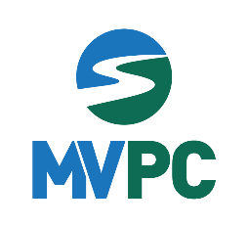
Merrimack Valley Transportation Committee
October 13, 2021
Agenda

- Welcome and Introductions
- Certification Review
  - Public Participation Plan Update and Outreach
- UPWP
  - Transportation Studies Progress
  - New Project Ideas
  - REPA grant - EV
- TIP
  - Project updates
  - Funding availability and project needs
- MVRTA Updates
- Safety Data for the Merrimack Valley

Discussion items for November meeting:
- Equity
- Public Participation Plan

