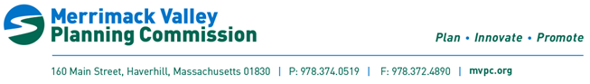
Merrimack River Collaborative Meeting
Tuesday April 25th, 2023
AGENDA
- Welcomes

- General Housekeeping
  - MRC team access
  - New agenda structure

- Planning and Collaboration
  - MRC & other legislation updates

- Outreach and Engagement
  - PFAS meeting with NMCOG

- Standardization and Monitoring

- Funding/Funded Projects
  - Early Alert Tool

- Open Discussion on Next Steps
  - Bi-monthly meetings, third Tuesday of every other month

Next Meeting: June 20, 2023

