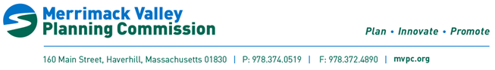
Merrimack River Collaborative Meeting
Tuesday February 13th, 2023
9-10am
Join Zoom Meeting
https://us06web.zoom.us/j/89048993835?pwd=BCPfFVUiLGQle6BIkreeGODsojoK5h.1&from=addon
AGENDA
- Welcomes

- General Housekeeping

- Planning and Collaboration
  - Annual water quality round table & MRC involvement
- Outreach and Engagement
  - MRC annual report full draft review
- Standardization and Monitoring
- Funding/Funded Projects
Early Alert Tool stakeholder meetings
- Open Discussion

Next Meeting Date: April; Dependent on Water Quality Roundtable Scheduling

