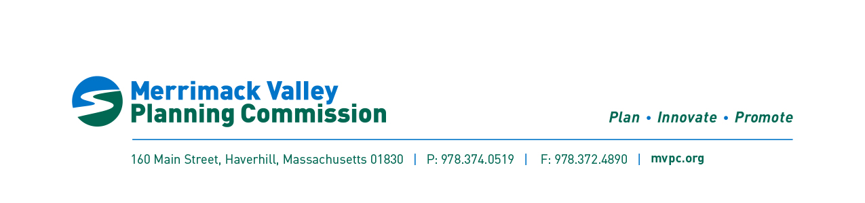

If you need this information in another language, please contact the MVMPO Title VI/Anti-Discrimination Coordinator at 978-374-0519.
Si necesita esta información en otro idioma, por favor contacte al coordinador de MVMPO del Título VI/Contra la Discriminación al 978-374-0519.
如果需要使用其它语言了解信息，请联系Merrimack Valley大都会规划组织（MVMPO）《民权法案》第六章协调员，电话978-374-0519。
Nếu quý vị cần thông tin bằng một ngôn ngữ khác, vui lòng liên hệ Điều Phối Viên Tiêu Đề VI/Chống Phân Biệt Đối Xử của MVMPO theo số 978-374-0519.
Si w bezwen enfòmasyon nan lòt lang, tanpri kontakte Kowòdinatè Tit VI/Kont Diskriminasyon an nan 978-374-0519.

Public Notice: Merrimack Valley Metropolitan Planning Organization Proposed Action, Public Hearings, and Comment Period
The Merrimack Valley Planning Organization (MVMPO) hereby gives notice of the availability of the following proposed action(s) for public review and comment:

Public Participation Plan Amendment

The above referenced action(s) are available for review on the Merrimack Valley Planning Commission (MVPC) website (www.mvpc.org/mvmpo) and are described below. The Merrimack Valley Metropolitan Planning Organization (MVMPO) invites the public to discuss the proposed action(s) and provide comments.

- Location: Virtual Meeting
- Date: January 13, 2025
- Time: 4:00pm
- Format: Office Hours: staff will be available to discuss the amendment, receive comments, or answer questions.
- Alternative ways to Participate: Written comments may be submitted to transportation@mvpc.org. Members of the public may also contact the transportation program to schedule a time to speak by phone or video chat.

Proposed Action(s):
This amendment updates the region’s federally required Public Participation Plan, developing new goals and values to encourage participation in the federal aid process. The amendment addresses public noticing, language requirements and translations, and virtual public engagement. The amendment also introduces new formats of engagement that may be considered for regional projects.

Join Us:
Meeting link:
https://us06web.zoom.us/j/81272638926?pwd=jt0xWwz4qNV5bzI31u1Q6fOu2zmvsq.1
Meeting ID: 812 7263 8926
Passcode: 494345

One tap mobile
+13017158592,,81272638926# US (Washington DC)

Meeting ID: 812 7263 8926
Find your local number: https://us06web.zoom.us/u/keEz1PLrot
For language or disability accommodations, please contact the MVMPO Title VI/Anti-Discrimination Coordinator at 978-374-0519, ideally a week in advance of the hearing date.

